The Priceless Brain decided to avoid regular “hard edge” or rectangular modular design style. We intend to portray the organic aspect of what it is we are designing: an automatic outdoor care system without your alternative lawn system being an eyesore or lacking functionality. Made of durable quality materials to protect and transport your SSLB system from the elements when not in use. The overall bot assessment will rely overall on its functionality, quality of materials used, and aesthetic..

**Self-Service Lawn Bots**

Project Proposal Document

Priceless Brains:

Carla Figueroa

Charles Lundin

Scott Mullinix

Sophia Neumann

Yengkong Sayaovong

**Division of work between the Brains:**

Carla Figueroa

Inter-Robot Collaboration

Proposed Individual SSLB//Hub

Charles Lundin

Inter-Robot Collaboration

Proposed Individual SSLB//DebrisBot

Scott Mullinix

Introduction

Proposed Individual SSLB//TrimBot

Sophia Neumann

Project Schedule

Back-Ups

Proposed Individual SSLB//LocatorBot

Yengkong Sayaovong

Project Schedule

Proposed Individual SSLB//MowBot

**Introduction**

**Problem Statement -**

The Priceless Brains have found that lawn-maintainers need a way to stay on top of their lawn care in a way that improves their lawn quality, and schedule management, while also freeing them from the physical requirements to do so.

**Priceless Brain Project Solution Intent -**

Our solution will aim to fill the needs of property owners, business owners and lawn care providers alike by providing a solution that doesn’t simply mow, like current model robotic mowers (1). Our solution will focus on providing a full yard-keeping system that will require minimal human participation for the physically unable. This system will be consistent with its quality and scope of work, safe for a bystander, and ultimately, energy conscious.

**Design Requirements -**

1) The devices shall have a safety to prevent it from turning on automatically.

2) The devices shall be able to be controlled via an app.

3) The devices shall provide an expected life of 5 years.

4) Devices shall be seismically qualified in accordance with requirements of IEEE

693.

5) Cellulose insulation barriers and spacers shall be high-density material.

Low-density pressboards are acceptable for forming insulation parts.

6) No split or star-locked washers permitted.

7) Devices shall be able to withstand wet ground conditions (water resistant).

8) Devices shall withstand a maximum wind speed of 5 mph.

9) Each device cannot weigh over 30 pounds.

10) To prevent overheating, cooling shall be integrated into the design.

11) Devices shall have the ability to schedule weekly lawn maintenance.

12) Devices shall have the ability to launch and dock themselves.

13) The devices shall provide a safety guard to prevent injury.

**Project Proposal Document Purpose -**

The purpose of this document will be to introduce you to the Self Service Lawn Bot (SSLB) project, its background, its intent and ideal execution. The document following includes: a proposal for each member of our robot swarm and their functionality; how the team of robots will interact with each other while executing their individual tasks and overall goal; a Gannt chart for our team’s schedule; the back-ups which include alternate bot ideas for the SSLB project with an alternate swarm task entirely incase the SSLB are too complex in comparison to TinkerCAD’s simulation capabilities.

**The SSLB Design Team -**

The SSLB team consists of 5 robots working in tandem. The SSLB//LocatorBot, designed by Sophia Neumann, is tasked with locating all the yard debris. In doing so, working with SSLB//DebrisBot, the team helps prevent damage to the mowing and weed whacking robots, or potentially affecting the pathing of the robots. SSLB//DebrisBot, designed by Charles Lundin, will proceed to clear the lawn of all the debris located by SSLB//LocatorBot. SSLB//Hub is our central hub, designed by Carla Figueroa. It’ll act as a base station, communicating with the customer allowing for scheduling, various notifications, act as a charging station for the robots and cover them from the elements. SSLB//TrimBot, designed by Scott Mullinix, will be a dedicated weed whacker robot that will edge around driveways, pavers or patios, while also trimming yard permitters along fencing; a feature current robot lawn mowers lack. Our final bot, SSLB//MowBot designed by Yengkong Sayaovong, is the mower. It will be capable of overlapping its path to prevent missed spots, create patterns, avoid permanent obstacles, and learn/relearn its perimeter for a thorough mow ensuring consistency.

**Proposed Individual Robots**

**SSLB//Hub - Carla Figueroa**

**Bot Functionality -**

This is the robot that stores, charges, transports, and protects mobile SSLB bots including: LocatorBot, DebrisBot, TrimBot, and MowBot. It has off-road tires for easy relocating ability and a trailer hitch; also available for stationed requirements wheel chocks for non-mobility where the customer wants it. This Hub is also where the customer can see an interface to control and track data when to use SSLB Robots daily, weekly, monthly, scheduling. This Hub is also responsible to guide and communicate with SSLB robots the desired boundaries to determine area of lawn care.

**Model Bot Design -**

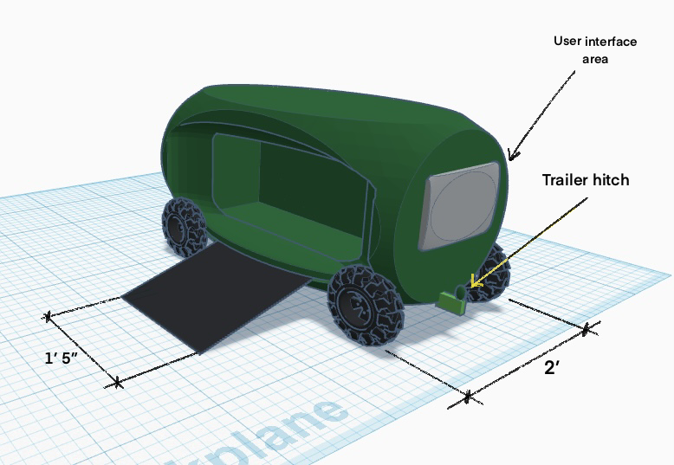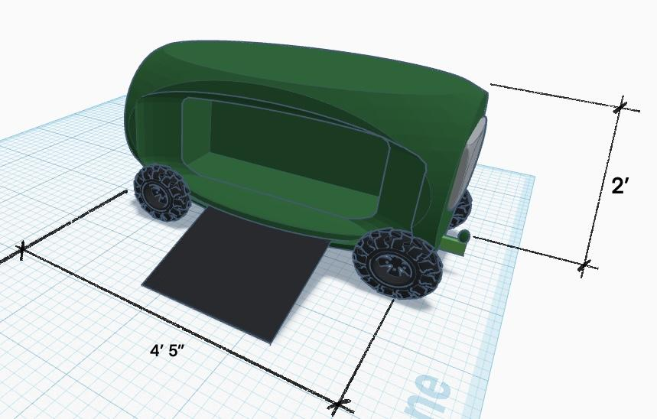

**Sensor/Actuator Configuration -**

* User Interface with Central hub controls sensors (computer)

Using a computer base system to track and run our proposed system algorithms. Also, to control sensors and have communication with all SSLB robots. Interface would show when robot parts need to be replaced as well, as a part of the customer’s notifications of the system. Specific charging/ storage station areas will be provided for all SSLB robots.

**Design Criteria Evaluation -**

**Key Features -**

* Stores and protects SSLB Robots
* Transports robots
* Control Hub/ interface to schedule maintenance
* Tracks data
* Determines area for SSLB to work on

**SSLB//LocatorBot - Sophia Neumann**

**Bot Functionality -**

The SSLB//LocatorBot will function mainly off of a DC motor and ultrasonic distance sensors controlled via Arduino. The distance sensors will locate objects while it is moving through the lawn, as well as avoiding obstacles by communicating left, right, forward, and reverse communications with the DC motor. The bot will communicate with the SSLB//Hub which will relay information regarding the lawn and obstacles to the other bots so that they can accomplish their tasks.

**Model Bot Design -**

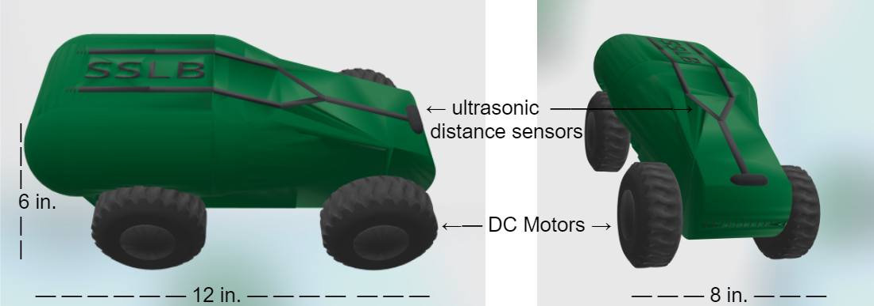

**Sensor/Actuator Configuration -**

* DC Motors
* Might utilize H-Bridge Motor Driver (L293D)
* Ultrasonic Distance Sensors

The configuration of elements used by the SSLB//LocatorBot include DC motors, H-Bridge Motor Driver, and ultrasonic distance sensors. These elements will be coded through Arduino to allow the bot to drive around and create a “land map” out of the information it gets from its sensors(2)(3). The DC motors (2 front and 2 back) will enable the movement of the bot, regarding forward, backward, left, and right. The movement of the bot will interact with the ultrasonic distance sensors (1 on each side) by utilizing it to track boundaries and avoid obstacles. Simultaneously, the location of boundaries and obstacles detected by the bot will be stored and transferred to the SSLB//Hub which will relay it to the other bots as necessary.

**Design Criteria Evaluation -**

Most of the design criteria that are important to the Priceless Brains would be assessed upon building a physical prototype, but since this is a virtual design, all that is currently feasible is judging it’s appearance along with the proportions of the design for durability. The Priceless brains team is looking for smoother and rounded corner bot designs, avoiding the 100% straight edge appearances. This design is sleek and rounded, and within the team selected SSLB branding colors of dark green with black accents. The “tank” design provides durability and the four wheels allow for greater stability and traction when navigating the lawn.

**Key Features -**

* DC motors working in tandem for left/right/forward/reverse motions.
* Creating a “yard map”
* Locates objects needing removal
* Longer wheel base (8x12) minimizes roll-over risk
* Four wheels adds stability

**SSLB//DebrisBot - Charles Lundin**

**Bot Functionality -**

Overall design and component connection is very simple. Basic DC motors will be able to move the bot through the yard base off the hypersonic sensors mounted on all sides of the bot which will allow the bot to determine through triangulation where it is relative to the boundaries in the central hub. Using this triangulation information, it will be able to seek and pick up via a “shovel” door that drops down. The robot will then scoop up using its own power and a topside scoop for the shovel to get the debris similar to how we use a broom and dustpan.

**Model Bot Design -**

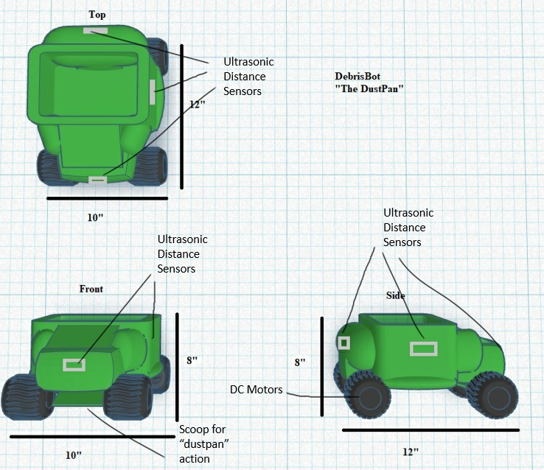

**Sensor/Actuator Configuration -**

The DebrisBot will have the following sensors:

* Ultrasonic distance sensors
* Dual DC motors
* Servo for “Dustpan” shovel
* Actuators to “sweep” in the debris

These devices will interface with an arduino microcontroller that will be coded to interpret the relative area map as received from the central hub to triangulate its location, and the location of the debris spotted by the locator bot. Once the bot is approaching identified debris, the scoop will be activated to lower via servo and it will maximize the torque available at the rear DC motors by slowly scooping, then an actuator will lower a “sweeping flap” to scoop the debris in like a dustpan and push the debris into the center debris storage bin.

**Design Criteria Evaluation -**

Physical Prototype aesthetics will make an impact for the end product. The effectiveness of the scoop for picking up the debris is very important. The ability for the robot to use low-speed, high torque to pick up small debris to limit damage to the motor as well as maintain the picked up debris in the removable bin will be important. Since the expectation for time in use will be rather low as a preparation for the major lawn work which will impact cost, battery life and weight.

**Key Features -**

* Dustpan Scoop
* Removable Debris Bin
* Dual Motor Design
* Wide wheels for max grip and maneuverability

**SSLB//TrimBot - Scott Mullinix**

**Bot Functionality -**

SSLB//Trimbot is driven by two, independent, DC motors driving the rear wheels. Able to drive in reverse of each other, it provides for a tight turning radius to avoid fixed obstacles detected by the LocaterBot and transmitted by the Hub. A center caster wheel provides a balance point for the bot as well. Distance from fixed obstacles is provided by distance sensors positioned on the nose and sides of the bot. Two additional motors power the two trimmer heads,that are refillable with standard wire on a spool. When it comes to trim the edges of a patio or driveway, the arms that hold the trimmer heads are independently able to rotate 90 degrees, depending on direction of travel of the bot.

**Model Bot Design -**

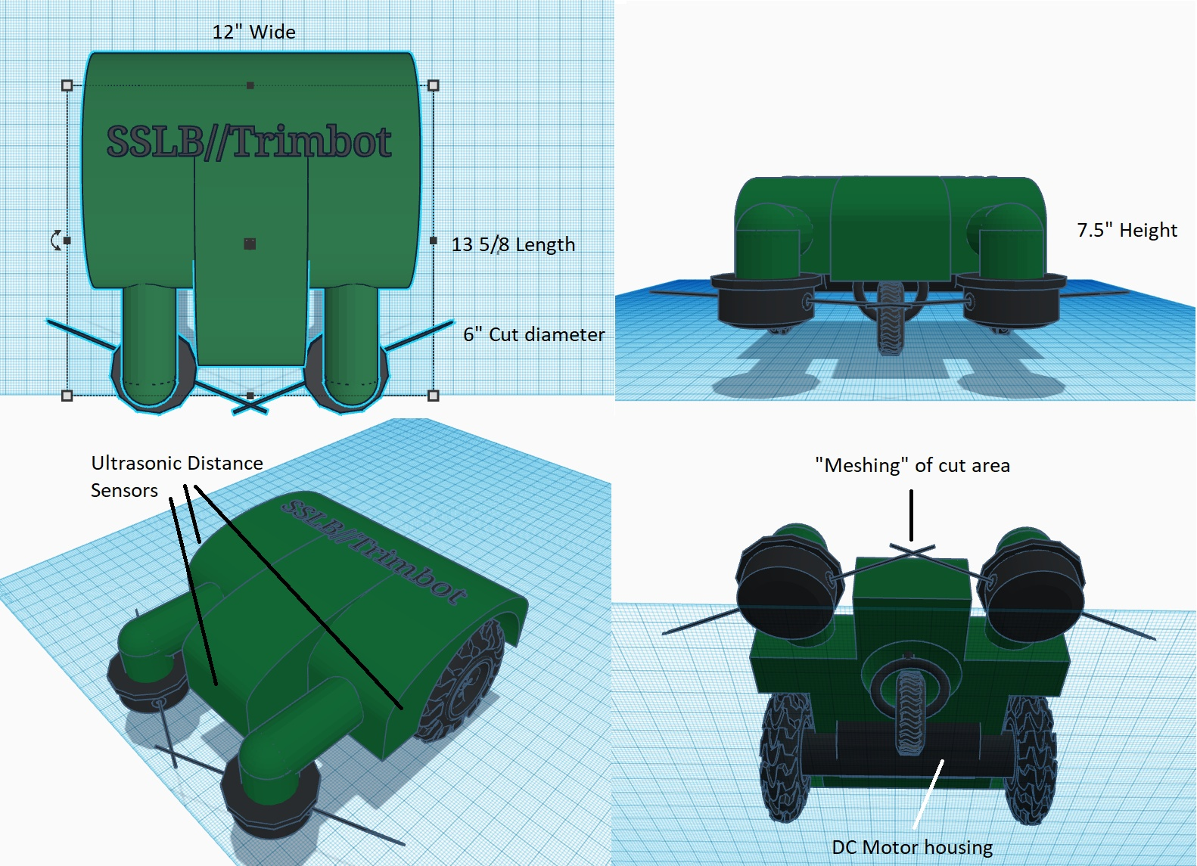

**Sensor/Actuator Configuration -**

* Servos to rotate trimmer arm
* DC Motors to drive trimmer head
* DC Motors to drive bot
* Ultrasonic distance sensors for guidance

The servos, motors and sensors would be coded in such a way that the drive motors would be driven to maintain a set standoff distance, as detected from the distance sensors, from a fence, railing, or object. This would allow the robot to cut the grass, while not needlessly using excessive string, causing extra cost due to replacement. The motors for the trimmer heads would be constantly driven and would only rotate 90 degrees if an edge of a patio or driveway were detected. The full suite of sensors used in a full scale robot would be (3) distance sensors, (2) DC drive motors, (2) servos to rotate the trimmer arms and (2) DC motors for the trimmer heads. For the proof of concept, a single sensor/motor for each configuration will be used.

**Design Criteria Evaluation -**

Quality of materials and battery life will be the largest criteria used to assess the success of this design. With multiple servos and drive motors, the potential exists for battery life to be poor and the need for the robot to dock, recharge and resume. While not a major issue for consumers, professional services would see this negatively as it’ll take longer to complete a job. Quality of materials will factor into the design with economical consumption of trimmer string. Using too much pressure on the string, from the robot traveling too closely to objects, will degrade it quicker, requiring more frequent replacement.

**Key Features -**

* Off road tires for use in wet lawns
* Dual trimmer design to trim from various directions
* Rotating trimmer arm allows device to edge patios and driveways
* Independently driven wheels for tight turning radius
* “Meshing” of trimmer string reduces chances for missed areas

**SSLB//MowBot - Yengkong Sayaovong**

**Bot Functionality -**

The overall design of the MowBot is a very simple design with a sensor in both front and back to detect how far an object is from it. The sensor will also be a trigger to tell the bot when to stop, go and turn. The MowBot will be able to cut the lawn with a 4-prong blade that is connected under the surface of the bot. The bot will be functioned off a DC motor and Arduino coding. The robot will also have a front guide to help balance the bot to not tip over when moving in motion.

**Model Bot Design -**

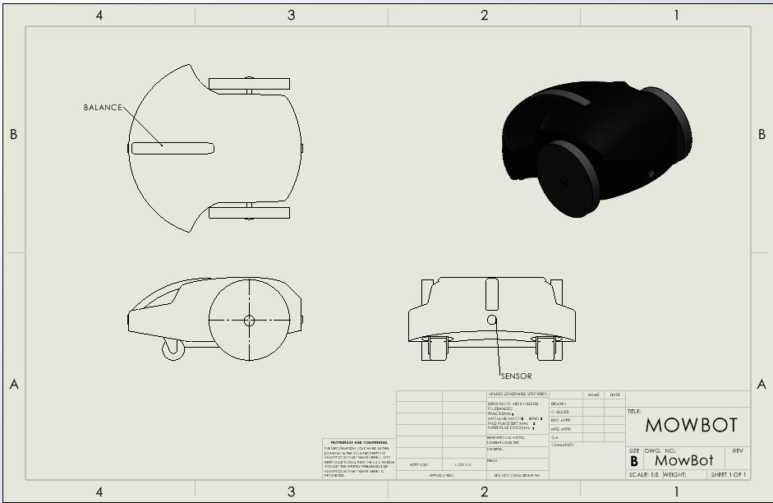

**Sensor/Actuator Configuration -**

* · Turning guide
* · DC Motor to drive bot
* · Front and back sensors for stopping, going, and turning

The turning guide is placed on the bot to help it not tip while mowing and turning corners. The sensors will be connected to an Arduino microcontroller that will allow it to sense the distance away from an object. The sensor lets the bot know to turn right or left and to move forward or back up. The DC motor will be placed on the bot to function it.

**Design Criteria Evaluation -**

The major design criteria of this bot is to have a longer battery life so that it can withstand a bigger yard as well. The bot will also need blades that are of quality to be able to cut the grass in one cut. The blades must also be able to be raised and lowered to give consumers an option of how low of a cut they would like their grass to be cut.

**Key Features -**

* Turning Rod to help with turning
* 4-blade underneath bot to cut grass
* Bigger back wheels to support stability
* Smaller swivel front wheels to help with turning.
* Sensor in back and front of bot to sense when object is close.

**Inter-Robot Collaboration**

**Collaboration and Coordination -**

The robots will communicate wirelessly via RF. The first robot will scan the area requested by the customer and find the debris and obstacles to create a yardmap at the central hub. It will then transmit this information to the other robots. The debris removal, weed wacker will then occur. The final robot will mow the remaining area.

**Initiation Information -**

LocatorBot will transmit the location information from the start of its cycle of the fence line/boundary and any debris that could interfere with the other bot’s information to the hub. The hub will then maintain this information for request by any app or other robot to ensure that, by location, the robots do not interfere with each other. The hub will also maintain current weather information so that they do not operate in a bad weather environment. Most essentially, all bots will be communicating: “where I am”, “what I am doing”, “I am done/waiting on previous task to complete” to each other.

**SSLB Actions -**

* LocatorBot - Defines the area on a grid relative to the yard area and finds the debris.
* Hub - Maintains the yard data and progress as well as acts as the app extender for the user.
* DebrisBot - seek and remove the items that would interfere with the mower(rocks/small sticks etc).
* TrimBot - follows the relative boundary line as discovered by the locator and trims the outside edges(fence, patio, pavers, etc).
* MowBot - Gets the bulk of the remaining yard, and can operate in tandem with TrimBot.

**SSLB Reactions -**

Each robot will have sensors to detect how close it is to each other as well as if the robot has veered off course. As soon as a robot enters its processing for collision detection or course correction it will pause until the correction needed is made. If needed, the hub can determine “tie breakers” for where each robot will go.

**Information Transmission -**

The Locator and DebrisBot will initiate the actions of TrimBot and the mower by sending an “I am done” and “At home” signal. Once these signals are acknowledged, the TrimBot will first come out of storage and head to the first area requiring trim. It will transmit a “starting job” signal to where the MowerBot will then also come alive and get started on its work. The hub will be the place that can confirm (where logs of recent actions happen) that these signals were received and can send them out to the requesting bots waiting for their next task.

**SSLB Pseudo-code/logic** -

The central hub we use the Arduino command Serial.print moves forward LocatorBot to use the robots sensors to sent information back to the central hub, a signal will be received to the central hub when scan with LocatorBot sensors ("Small organic matter: location(s):" (x,y),ect.) serial.print send location of items to central hub. LocatorBot will receive a signal to come to the central hub for charging protocol. Central hub command Serial.print moves forward DebrisBot using information collected from LocatorBot, DebrisBot moves forward to conduct small organic matter (small rocks or sticks) collection, after DebrisBot returns to central hub, both first and second robot sends “i’m home” signal to MowerBot to move forward. MowerBot command Serial.print moves forward to conduct cutting the lawn.

**Project Schedule (Red line = milestone)**

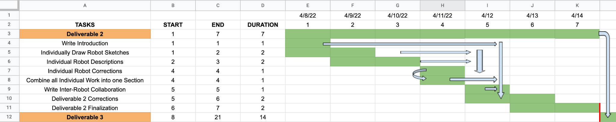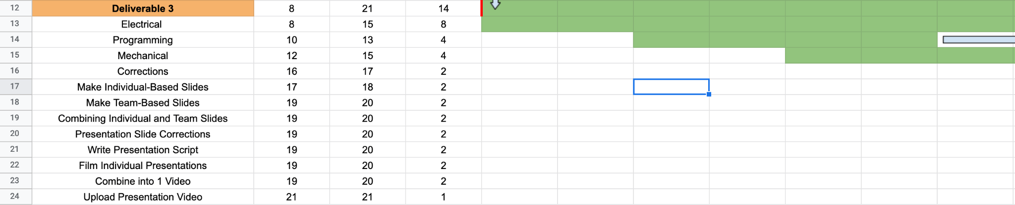

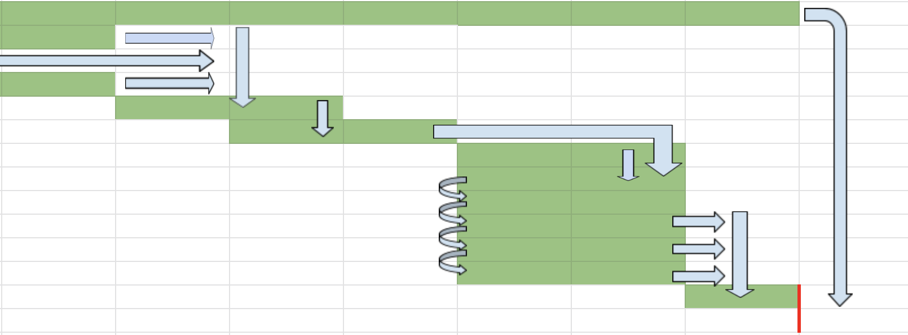

**Link:** [**https://docs.google.com/spreadsheets/d/1SZS4g8NnrTnNTp_98aEuzhEAnLMXmKuN_RrGGBvLQ48/edit?usp=sharing**](https://docs.google.com/spreadsheets/d/1SZS4g8NnrTnNTp_98aEuzhEAnLMXmKuN_RrGGBvLQ48/edit?usp=sharing)

**Back-Ups**

If any of our SSLB proves to be too complex or complicated to design, we have a couple of back up designs to try. One would be to add another mower bot in order to increase the time efficiency of how long it takes the SSLB to do a lawn from start to finish. Yet another solution would be to create a bot that would go over the lawn, after the other bots are finished working, spraying a fertilizer and/or pesticide.

If overall the duties of the SSLB prove to be too complex overall, we will go forward with a new swarm task of planting a garden. Some examples of jobs that each bot could do are tilling up the dirt, making planting rows, dropping the seeds in the dirt, covering all the seeds, and watering the seeds.

**References**

1. Muller, Matthias. “10 Problems with Robotic Mowers You May Not Be Aware Of.” Robolever, 2 Nov. 2020, https://robolever.com/10-problems-with-robotic-mowers-you-may-not-be-aware-of/.
2. Shadman Fahim Ahmad, and Abrar Hasin Kamal. “Ultrasonic Sensor Based 3D Mapping & Localization - ResearchGate.” *ResearchGate*, Apr. 2016, https://www.researchgate.net/publication/315624159_Ultrasonic_Sensor_Based_3D_Mapping_Localization.
3. Tunai Porto Marques, and Fumio Hamano. “(PDF) Autonomous Robot for Mapping Using Ultrasonic Sensors - Researchgate.” *ResearchGate*, Nov. 2017, https://www.researchgate.net/publication/323056345_Autonomous_robot_for_mapping_using_ultrasonic_sensors.